PHP Lab

Assignment - 3

Dated: 25-02-2021

Sub Code: CSE-230

**Vivek Kumar Ahirwar**

**191112419**

**CSE - 3**

Department of

Computer Science and Engineering

Subject Coordinator:

Prof. Rahul Shrivastava



**Maulana Azad**

**National Institute of Technology,**

**BHOPAL – 462 003 (INDIA)**

Contents

Form Validation 2

Code 2

Output 6

# Validation Form

Online Hosted Assignment Website Link: <http://php-vivek-repo.mywebcommunity.org/>

## Code

<!-- 191112419 -->

<!DOCTYPE html>

<html lang="en">

<head>

    <style>

        .error {

            color: #FF0000;

        }

        .button {

            border: none;

            color: white;

            padding: 15px 32px;

            text-align: center;

            text-decoration: none;

            display: inline-block;

            font-size: 16px;

            margin: 4px 2px;

            cursor: pointer;

            background-color: #008CBA;

        }

        body {

            background-color: #f5fafd;

        }

    </style>

    <meta charset="UTF-8">

    <title>Form Validation</title>

</head>

<body>

    <?php

    $nameErr = $emailErr = $genderErr = $ageErr =  $mobileErr = "";

    $name = $email = $gender = $age = $mobile = "";

    $pattern = "/^[a-zA-z]*$/";

    if ($_SERVER["REQUEST_METHOD"] == "POST") {

        //Name

        if (empty($_POST["name"])) {

            $nameErr = "Name is required";

        } else {

            //Name format check

            if (!preg_match("/^[a-zA-z]*$/", $_POST["name"])) {

                $nameErr = "Invalid Name Format";

            } else {

                $name = test_input($_POST["name"]);

            }

        }

        //Age

        if (empty($_POST["age"])) {

            $ageErr = "Age is required";

        } else {

            //Number format check

            if (!preg_match("/^[0-9]*$/", $_POST["age"])) {

                $ageErr = "Invalid age format";

            } else {

                $age = test_input($_POST["age"]);

                if (!($age >= 20 && $age <= 40)) {

                    $ageErr = "Invalid age! <em>Age must lie between 20 to 40</em> ";

                }

            }

        }

        //Gender

        if (empty($_POST["gender"])) {

            $genderErr = "Gender is required";

        } else {

            $gender = test_input($_POST["gender"]);

        }

        //Email

        if (empty($_POST["email"])) {

            $emailErr = "Email is required";

        } else {

            $email = test_input($_POST["email"]);

            // e-mail format check

            if (!filter_var($email, FILTER_VALIDATE_EMAIL)) {

                $emailErr = "Invalid email format";

            }

        }

        //Mobile no.

        if (empty($_POST["mobile"])) {

            $mobileErr = "";

        } else {

            //number format check

            if (!preg_match("/^[0-9]*$/", $_POST["mobile"])) {

                $mobileErr = "Invalid mobile no. format";

            } else {

                $mobile = test_input($_POST["mobile"]);

                if (strlen($mobile) != 10) {

                    $mobileErr = "Mobile no. must be 10 digit number";

                }

            }

        }

    }

    function test_input($data)

    {

        $data = trim($data);

        $data = stripslashes($data);

        $data = htmlspecialchars($data);

        return $data;

    }

    ?>

    <h1 align="center">Registration Form </h2>

        <h3>Vivek Kumar Ahirwar</h3>

        <h3>191112419</h3>

        <h3>CSE-3</h3>

        <p><span class="error">* required field.</span></p>

        <form method="post" action="<?php $_SERVER["PHP_SELF"] ?>">

            <table>

                <tr>

                    <td>Name:</td>

                    <td><input type="text" name="name">

                        <span class="error">* <?php echo $nameErr; ?></span>

                    </td>

                </tr>

                <tr>

                    <td>Age:</td>

                    <td> <input type="text" name="age">

                        <span class="error">* <?php echo $ageErr; ?></span>

                    </td>

                </tr>

                <tr>

                    <td>Gender:</td>

                    <td>

                        <input type="radio" name="gender" value="female">Female

                        <input type="radio" name="gender" value="male">Male

                        <span class="error"> &emsp; &emsp;* <?php echo $genderErr; ?></span>

                    </td>

                </tr>

                <tr>

                    <td>E-mail: </td>

                    <td><input type="text" name="email">

                        <span class="error">* <?php echo $emailErr; ?></span>

                    </td>

                </tr>

                <tr>

                    <td>Mobile no:</td>

                    <td> <input type="text" name="mobile">

                        <span class="error"> <?php echo $mobileErr; ?></span>

                    </td>

                </tr>

                <tr>

                    <td></td>

                </tr>

                <tr>

                    <td></td>

                    <td><input type="submit" class="button" name="submit" value="Submit"></td>

                </tr>

            </table>

        </form>

        <?php

        echo "<h2>Your given values are as:</h2>";

        echo $name;

        echo "<br>";

        echo $age;

        echo "<br>";

        echo $gender;

        echo "<br>";

        echo $email;

        echo "<br>";

        echo $mobile;

        echo "<br>";

        ?>

</body>

</html>

## Output

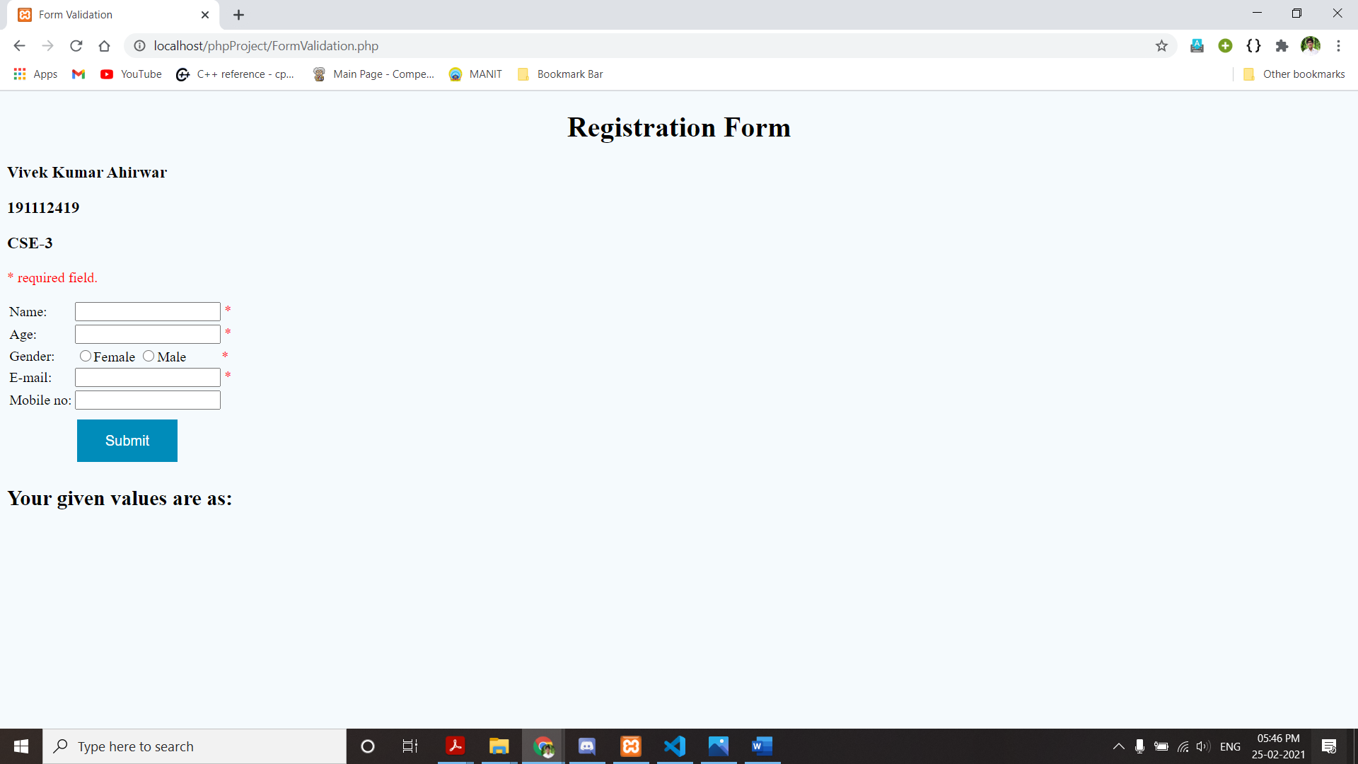

Valid Input formats

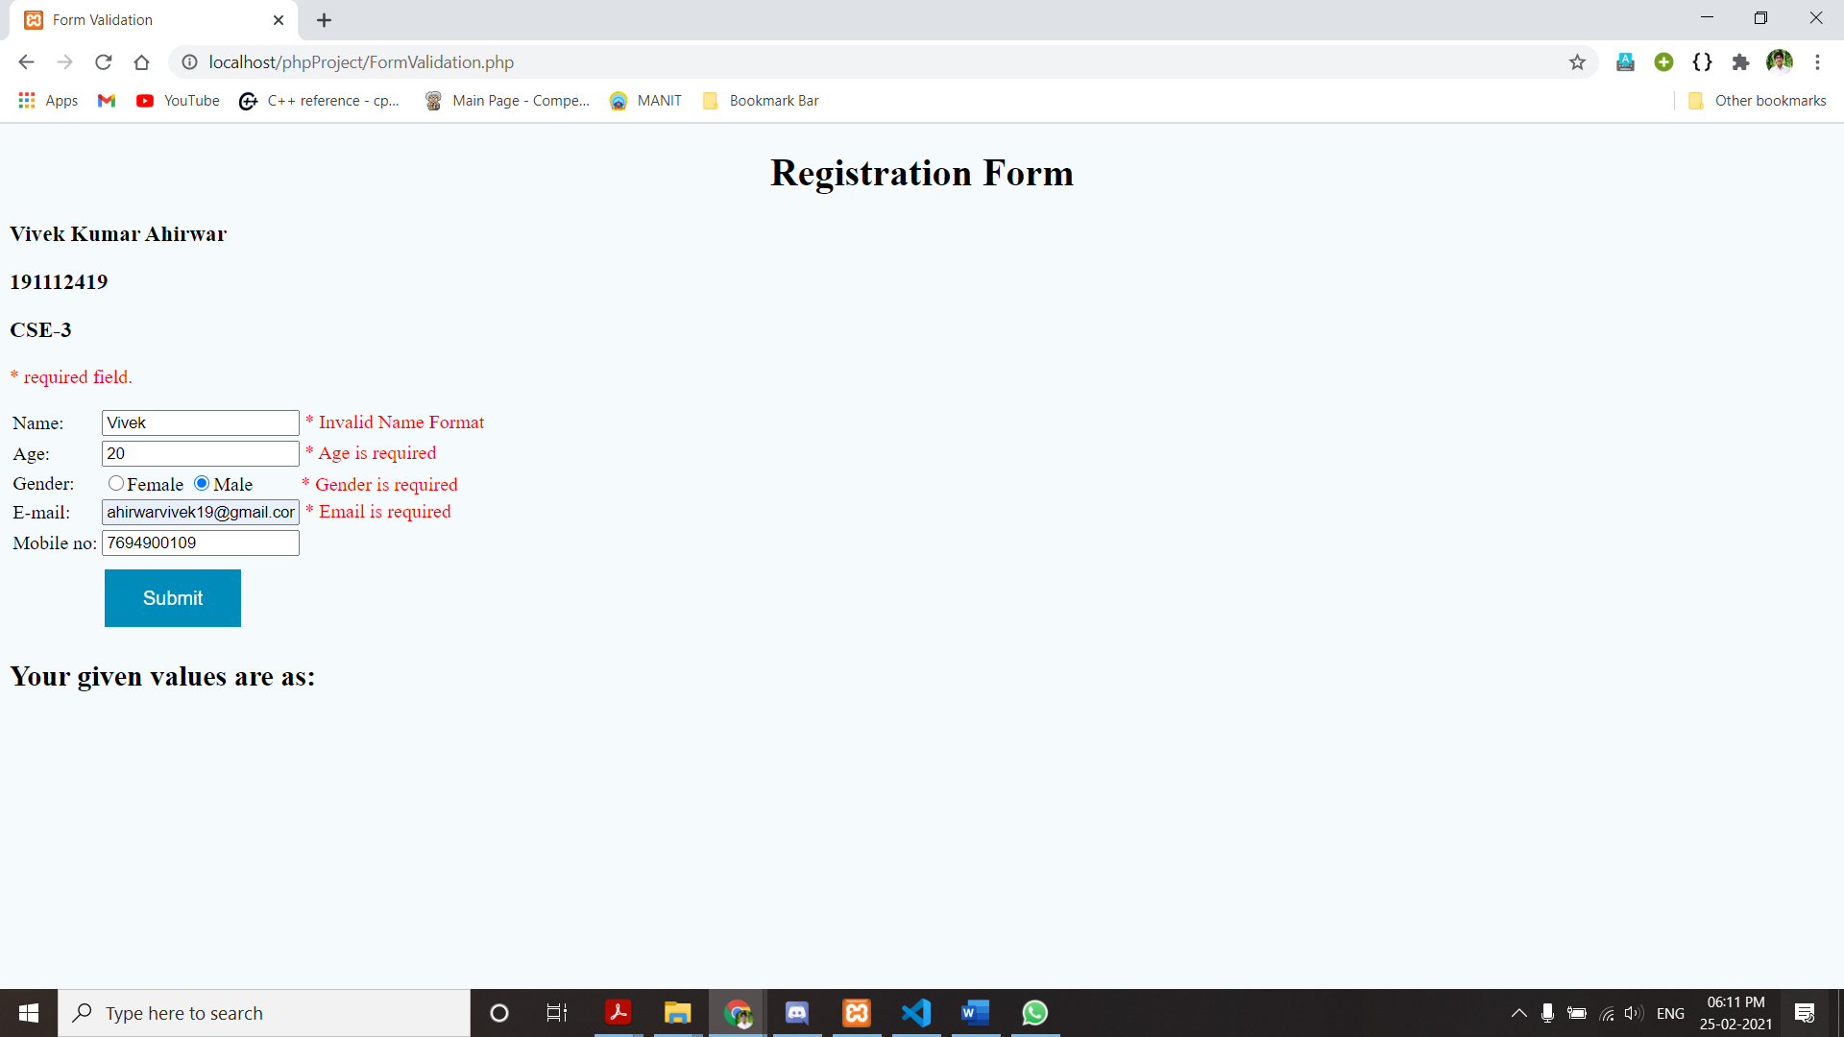

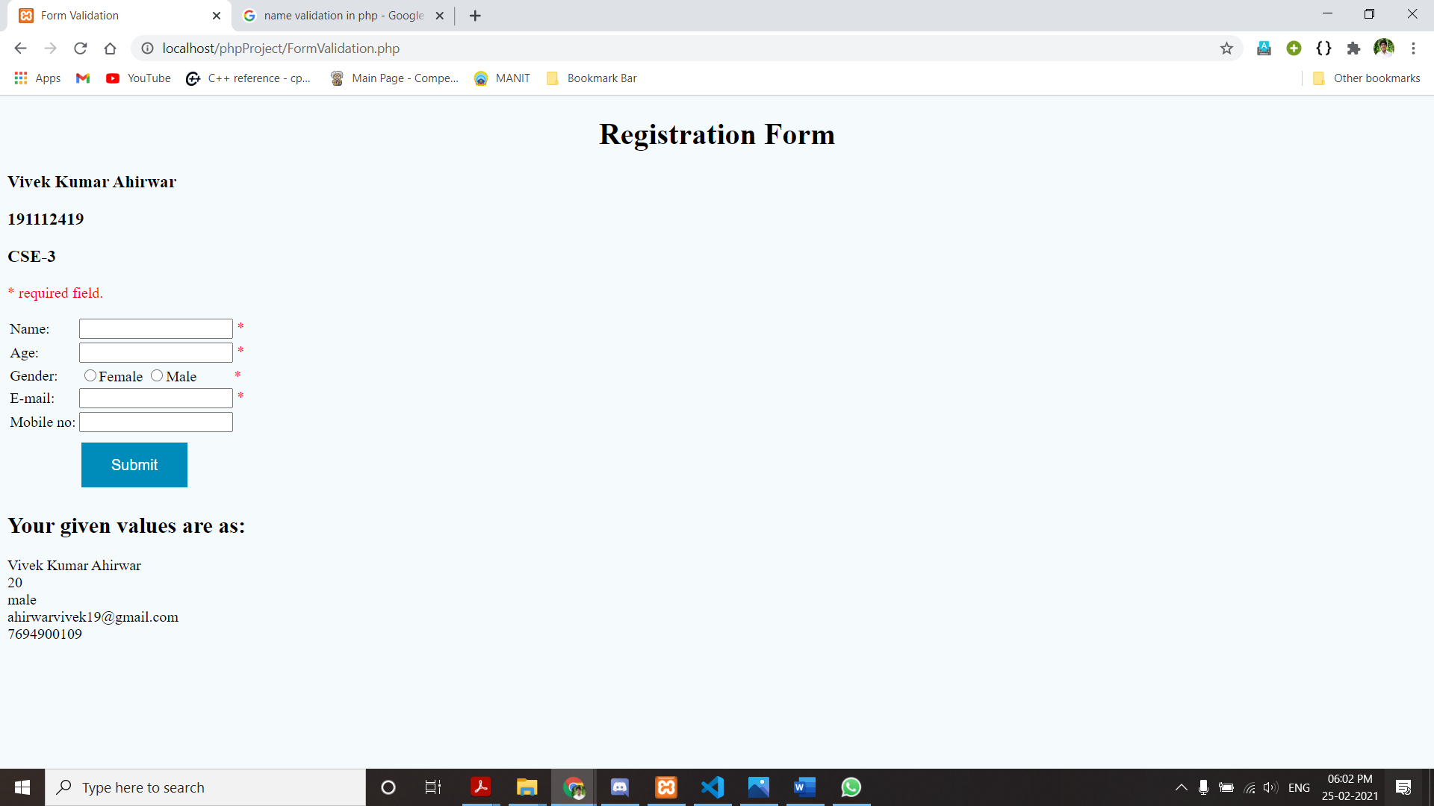

Invalid Inputs format

